Tips & Tricks for Bacon Buddies® Show Organizers

Keys for a successful event:
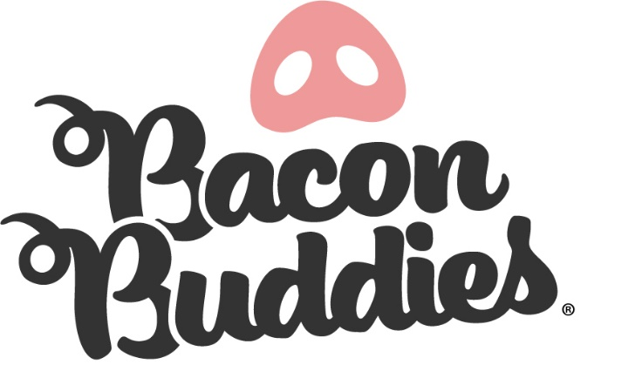
- Be flexible! It is ok if things don’t go 100% as planned, be prepared to make changes on the fly
- Be patient with participants and pigs!
- Be supportive of reactions of the participants (many of them this might be their first time around a pig).
- Be cognizant of sensory sensitivity (noises, space, lighting, crowds, cameras, pigs, water, shavings).
- This is an experience; everyone is a winner! All Buddies should receive the same prize for their participation.

Logistics
Checklist:
- Space: make-up ring, show ring, area for participants to collect ribbons after they exit the showring
  - Allows for parent/guardian to reunite with Buddies, and pig owner to locate and put away pig.
- Show equipment
  - Show sticks, brushes, spray bottles, sorting board, etc.
  - Who provides these? Are they borrowed from pig owner or the mentor?
- T-shirts (if provided)
  - Consider making t-shirts different based on involvement (buddy, youth mentor, volunteer)
Things to consider:
- Have audience (i.e. “fan zone”) located where participants exit the show ring
  - Provides encouragement, high-fives, congratulations, etc.
  - As participants make their way to the designated space where parents/guardians reunite with Buddy
- Creating name tags for those involved
- Photo backdrop availability and location approximate to showring
Analyze your event (Location, facilities, parking, audience, and support)
Checklist and things to consider:
- Event location
  - Is it handicap accessible? Are there bathrooms nearby? Consider comfort for participants and audience
- Timeframe of event
  - Consider time of day, temperature, traffic to venue, audience support
- Parking
  - Is it close to the location of the event for participants not familiar with area? Consider handicap parking accessibility
- Admission
  - Is there admission to the event or fair? Who covers the cost for participants?

Identifying Buddies (Special Olympic Iowa Athletes)
Checklist and things to consider:
- Highly suggest working with an organized group (ex.: Special Olympics, local school district, etc.) to identify “Buddies”
  - Recommend contacting Dawn Criss (Special Olympics Iowa Director of Regional Field Services)
    - Email: dcriss@soiowa.org
- Parental or guardian consent is required
Identifying Youth Mentors (4-H and/or FFA)
Checklist and things to consider:
- Select Mentors with high moral regard, appropriate maturity level and/or age
- Mentors are not required to have swine exhibits
  - Swine exhibits can be used from another showman
- Mentor should be calm, patient, encouraging, and can adapt to different situations

Identifying Volunteers
Checklist and things to consider:
- Volunteer Tasks
  - Distributing t-shirts
  - Help moving pigs from pens to the make-up area/showring
  - One to two in the make-up ring to assist exhibitors (a sorting board may be helpful)
  - Two to three volunteers in the showring to assist if necessary (a sorting board may be helpful)
  - Two volunteers should be present on the exiting side of the show ring to help participants make their way out
  - Two volunteers to assist with photos after the participants exit the show ring (with awards, Buddies, and Mentors)
- Volunteer Selection
  - Kind and patient
  - Passionate about kids and pigs
  - Flexibility and willingness to help wherever the need arises during event
  - Must be available through entire event
  - Volunteers should be identified and notified of their role prior to the event
Selection of Judge/Emcee
Things to consider
  - Kind, compassionate, patient, sensitive to situations
  - Ability to read people and situations (participants that are nervous, shy or don’t want to talk on the mic, etc.)
  - Ability to think/adjust on the fly
  - Charismatic on microphone
  - Aware of the importance of the event

Pigs
Checklist and things to consider:
- Will the pigs be used in other shows throughout the event?
  - either the day(s) prior or after)
- Pigs should be calm and have adequate level of training
- Whose pigs will be used for the event? Are 4-H or FFA pigs already on site?

Class Size and Duration
Checklist and things to consider:
- No matter the show ring size, we suggest no more than 4 or 5 “Teams” in a class
  - This allows the participants to stay engaged
- We suggest the entire “show” should last no longer than an hour

Public Relations
Checklist and things to consider:
- Photography and/or videography
- Advertising
  - Use hashtag #BaconBuddiesIowa to showcase your event on social media
  - Consider social media, print, radio, television
- Media requests
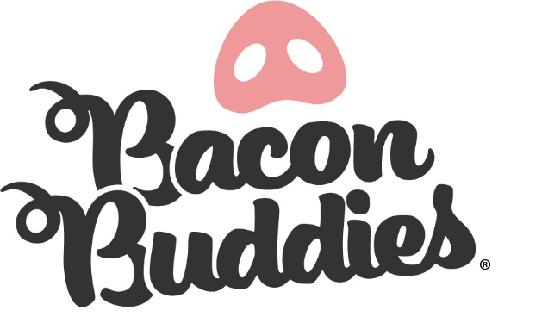
  - Before, day of, during and after event

Sponsorship
Checklist and things to consider:
- Participant awards (ribbons for all Buddies)
- T-shirts
- Photo backdrop
- Meal/Refreshments/Snacks

